LAST DAY OF NETAJI SUBASH CHANDRA BOSE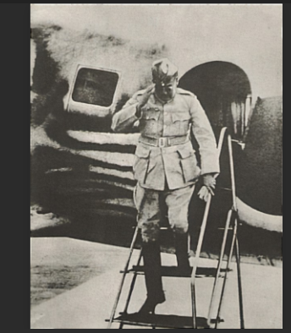 Netaji Subash Chandra Bose has planned to send to out the British from India with the help of Japan in between The World War II. But unfortunately, on August 6th, 1945 in japan the nuclear bomb has been released by America at the cities of Hiroshima and Nagasaki. On 15th August, 1945 Japan has surrendered. Netaji heard about this news and he planned to get help from other country. So he went from Singapore to Vietnam, from Vietnam he wants to go to a particular town in China, this was the plan. From China they want to go to Russia for the help, because already British and Russia is having some clash. From Vietnam they want to have a small stop in Taiwan for refueling and from there to China, this was their trip plan. On 18th August 1945 they are getting ready to leaving from Vietnam, for that they are taking one flight, it was a Japanese Army Flight. The flight capacity is generally 5 persons can go, but on that day with Subash Chandra Bose 12 persons has travelled with him. They are leaving from Vietnam, when they are travelling pilot has a doubt that engine is having some problem, so before going to Taiwan they having one stop at Vietnam. In that stop they are refueling the flight, all of them taking rest for 2 hours and they are checking the flight. After that they are going to Taiwan, after going Taiwan they are landing the flight. When they take off the flight from the runway, in a couple of seconds, those who are in the airport seeing that an object is felling down from the flight and it gives a big sound. The people is seeing what it is, they saw the right engine of the flight has fallen down. At that time the flight has turning round 2 times and broken down into 2 pieces and falling down. After falling, the 2 pilot has died immediately but Subash Chandra Bose is still alive but the problem is, in his body there is fully petrol and gasoline. In outside the flight has got started to fire, he is trying to get out from the flight and he came out but unfortunately there is fully petrol and gasoline in his body, so his body started to get fire. He is running from the flight with his fired body, the Japanese are telling that how a person can run with this fired body? Then the survivors are coming and they closing his body with the blanket, meanwhile passengers are in inside the flight but they are survived. Then they are taking Subash Chandra Bose to the hospital. This incident has happened at 2pm and they are doing surgery for him upto 6pm. After that he is getting into coma and at 9pm he has died.